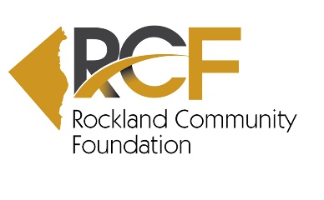
Program Associate – Part-time (20-30 hours per week)
The Rockland Community Foundation is looking for a motivated Part Time Program Associate to assist and/or spear-head various tasks at the Foundation including scholarships, grant requests, social media posts and special events.
Key skill sets for this position include:
- Associates degree or higher required.
- Two or more years of relevant work experience preferred.
- High ethical standards, requiring honesty, integrity, respect and confidentiality.
- Strong computer skills, especially Microsoft Office products. Willingness to become proficient with database and scholarship software specifically designed for foundations.
- Excellent organizational and administrative skills as well as time management and project management
- Excellent written and verbal communication skills for substantial public contact with a diverse array of individuals.
- Excellent interpersonal skills with strong customer service
- High level of self-motivation and at ease working independently when necessary
- Organized, with exceptional attention to detail, and strong follow-through skills.
- Some accounting knowledge a plus.
- Ability to work flexible hours when required.
- Networking track-record in Rockland County and/or experience with a nonprofit org in Rockland County would be a plus.
This position is fully remote but would require in-person meetings on occasion. CANDIDATES MUST RESIDE WITHIN ROCKLAND COUNTY OR NORTHERN BERGEN as travel within the region will occur. The hourly salary range for this position is between $24 and $28/hr. commensurate with relevant experience.
The Rockland Community Foundation is an equal opportunity employer.
Interested? Email your cover letter and resume to info@rocklandgives.org

